Name: Jessen  
Student ID: 2602073800

Penjelasan Website

Penjelasan per halaman website:

1. Home Page

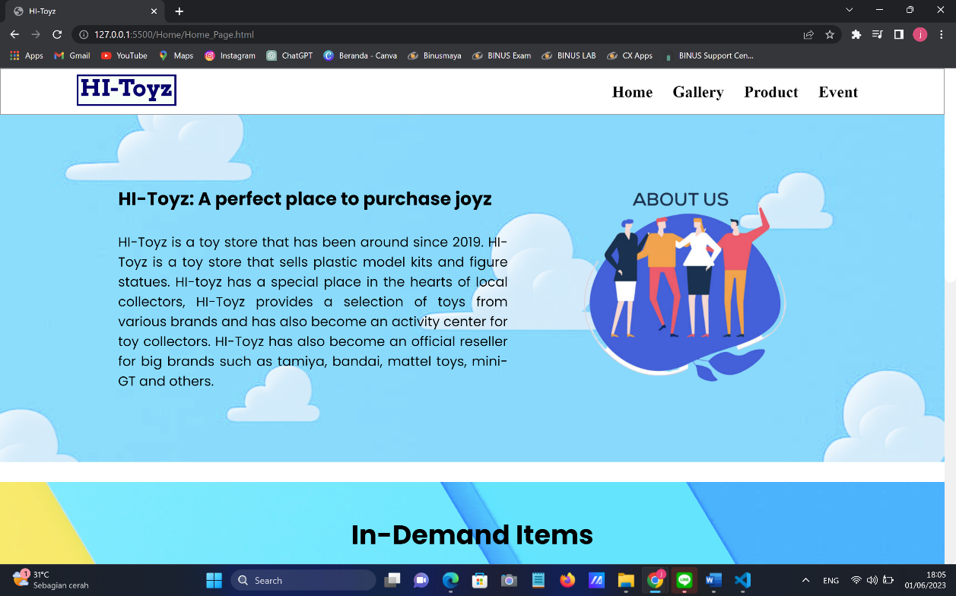

Halaman ini akan menampilkan latar belakang dan sejarah didirikannya HI-Toyz beserta slogan dari HI-Toyz yakni “A perfect place to purchase joyz”, dengan slogan ini HI-Toyz ingin meyakinkan para konsumen bahwa Hi-Toyz merupakan tempat yang tepat untuk membelikan mainan bagi sang buah hati.

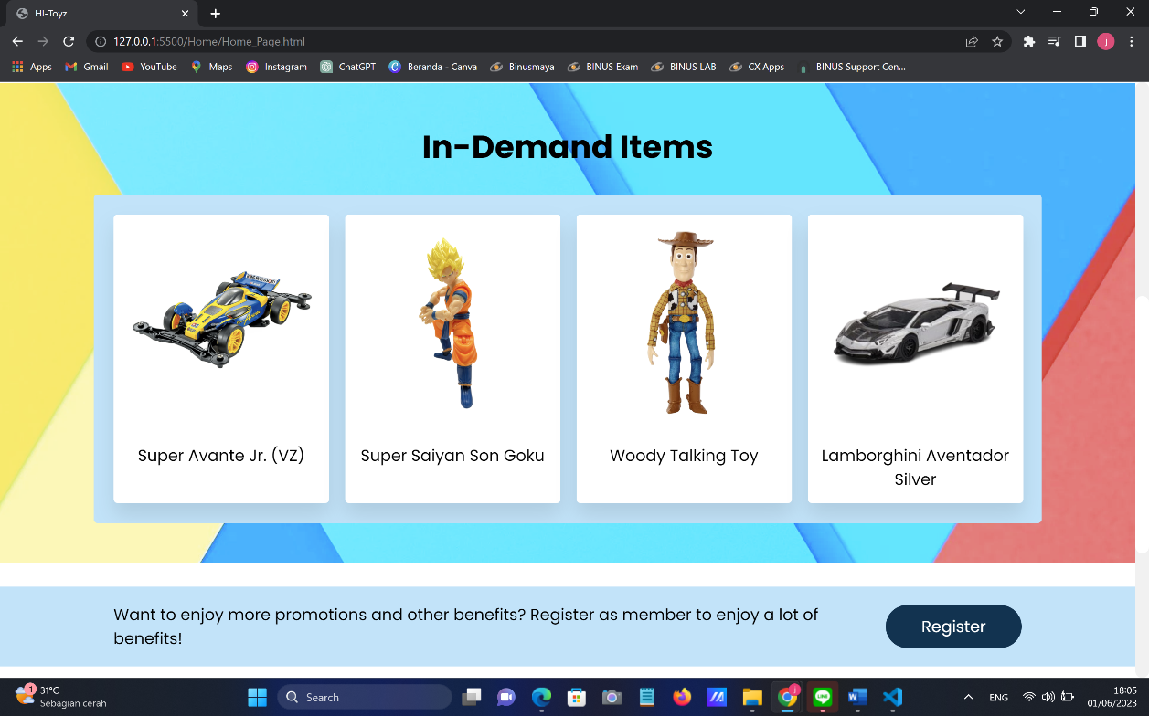

Halaman ini juga menampilkan beberapa mainan yang paling laris dalam beberapa hari terakhir.

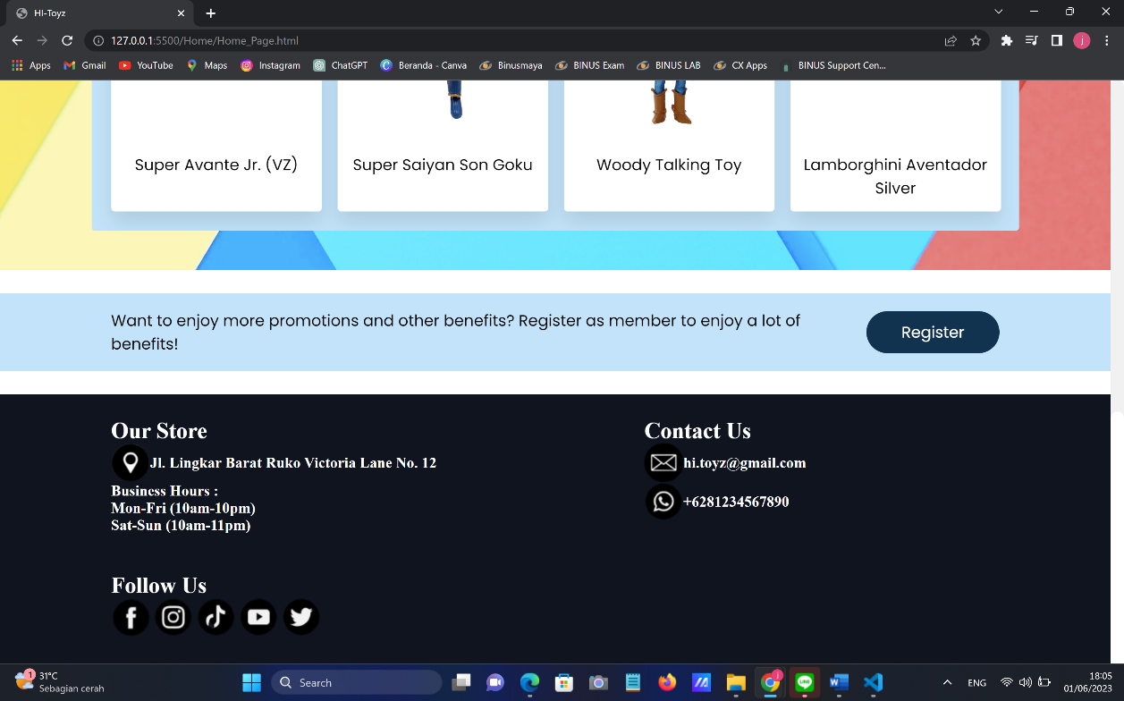

Terakhir, halaman ini menampilkan satu bagian untuk mengajak para pengguna baru untuk mendaftarkan diri sebagai member dari HI-Toyz dan nantinya member dapat merasakan banyak keuntungan berupa berbagai promosi dan keuntungan lainnya yang bisa dilihat di menu “Event”.

1. Register Page

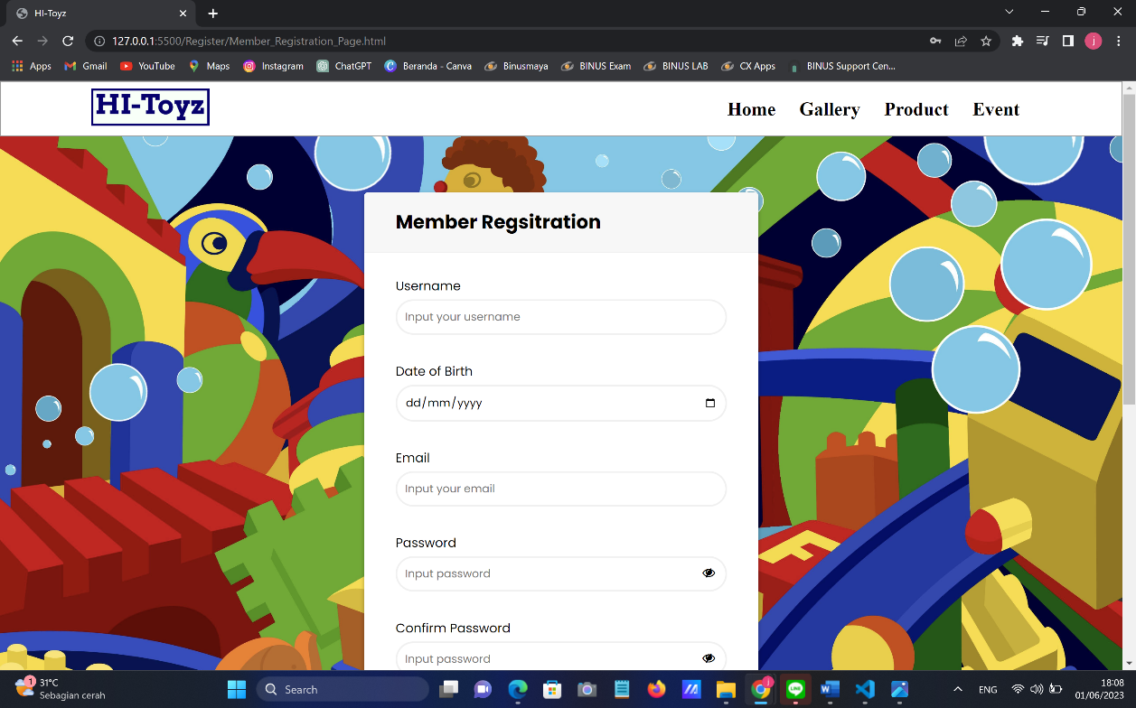

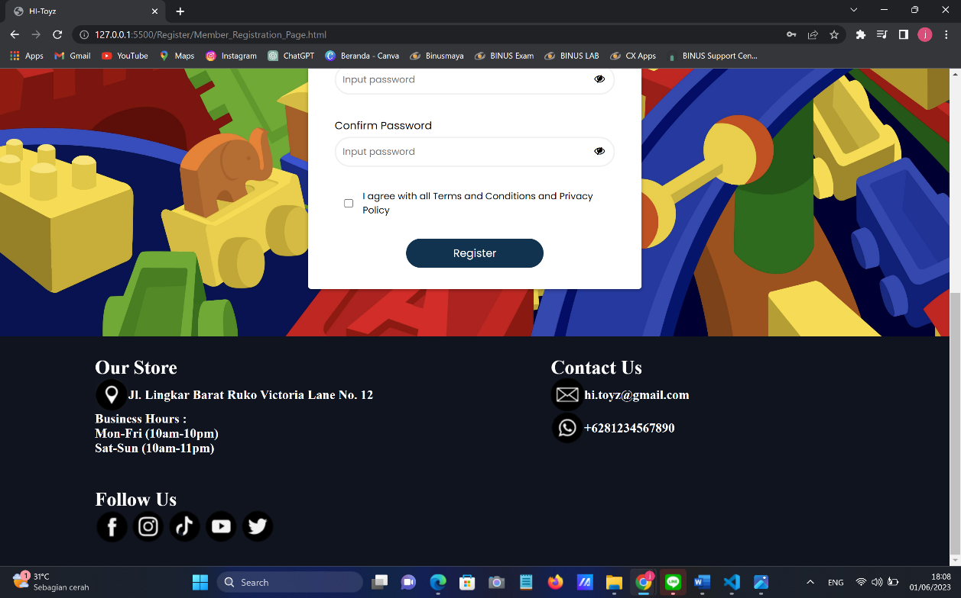

Halaman ini merupakan tempat dimana para pengguna bisa mendaftarkan diri sebagai member dari HI-Toyz. Ada beberapa informasi pribadi yang harus diisi yakni nama, tanggal lahir, email, password dan persetujuan terhadap syarat yang berlaku.

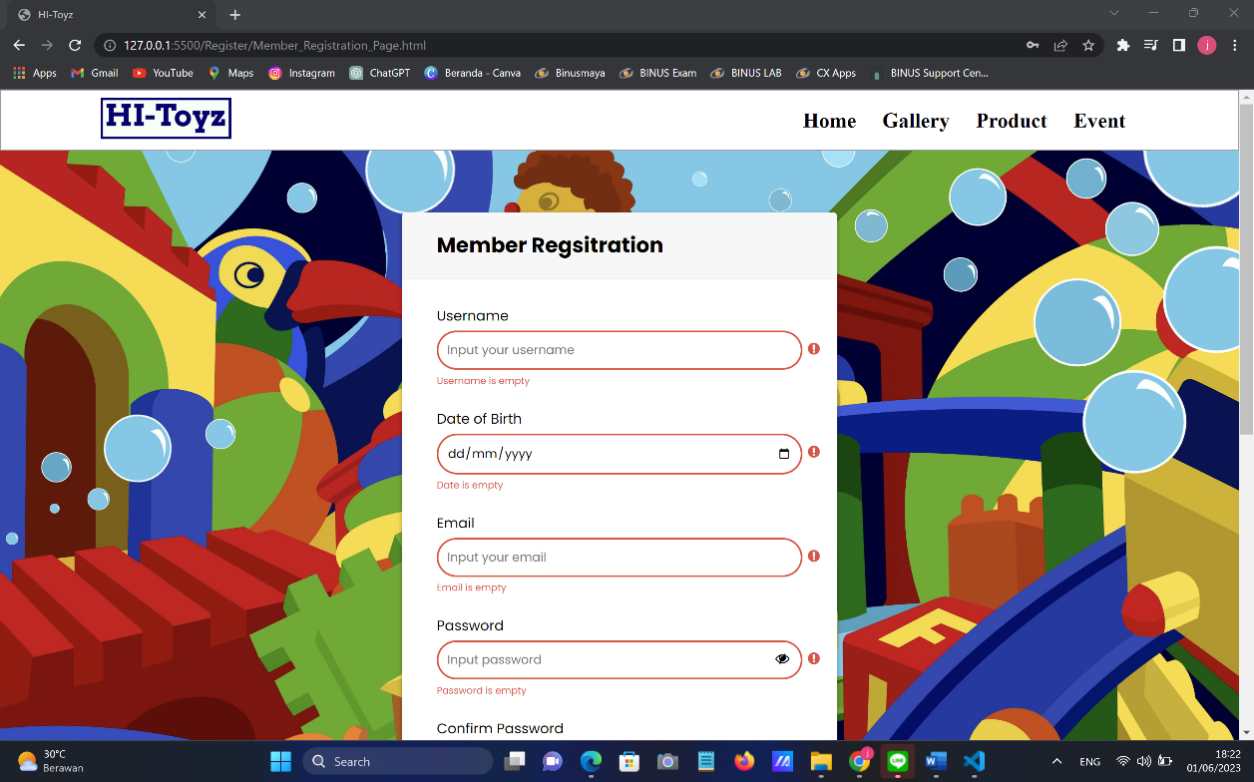

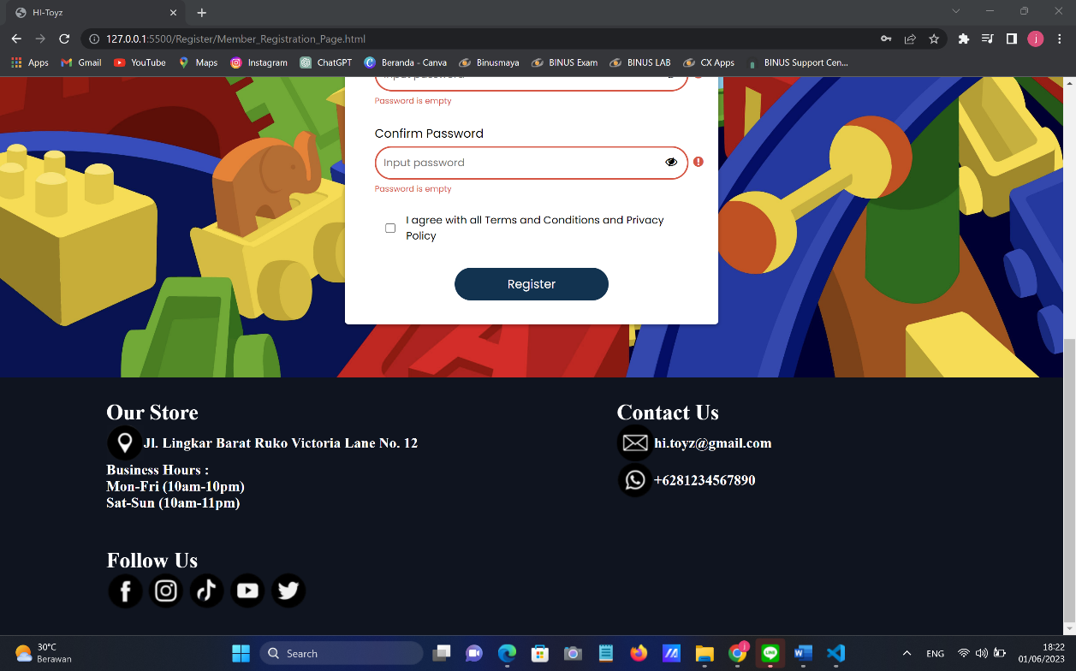

Jika pengguna menekan tombol register pada saat kotak belum terisi maka sistem akan menampilkan pesan yang menyatakan bahwa kotak masih belum terisi.

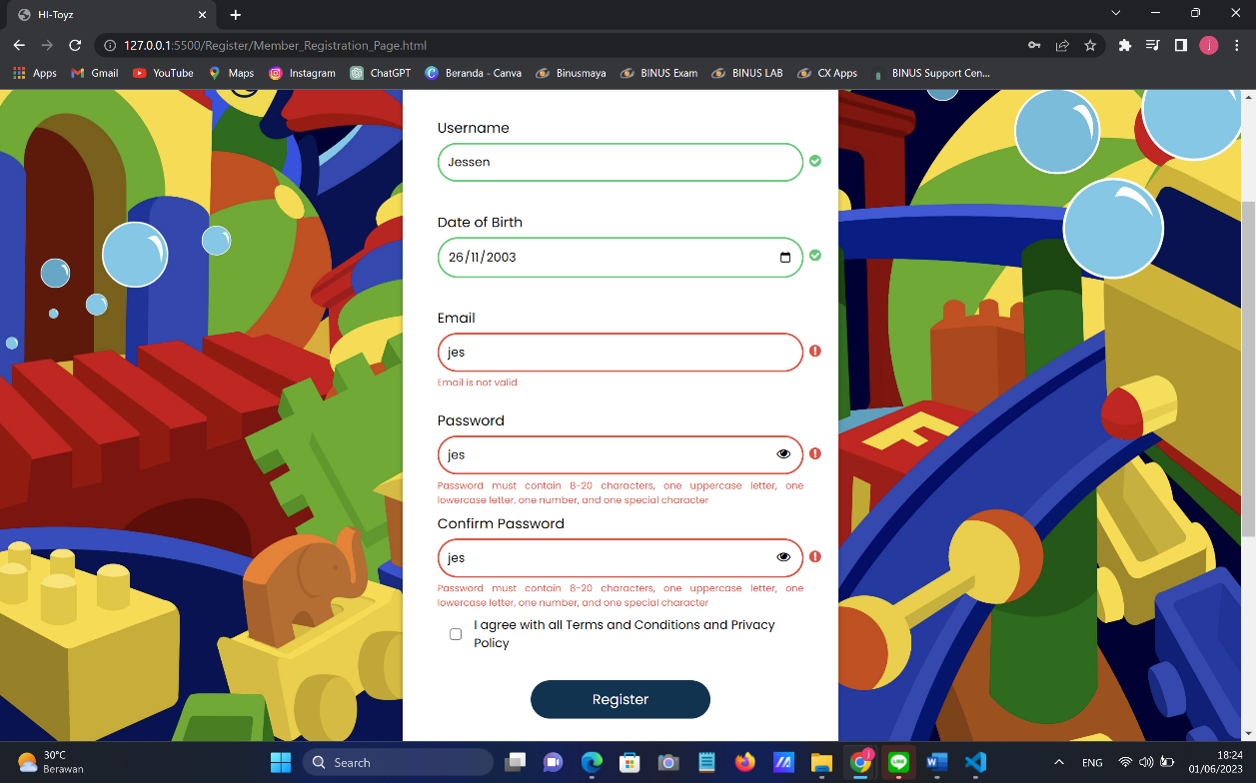

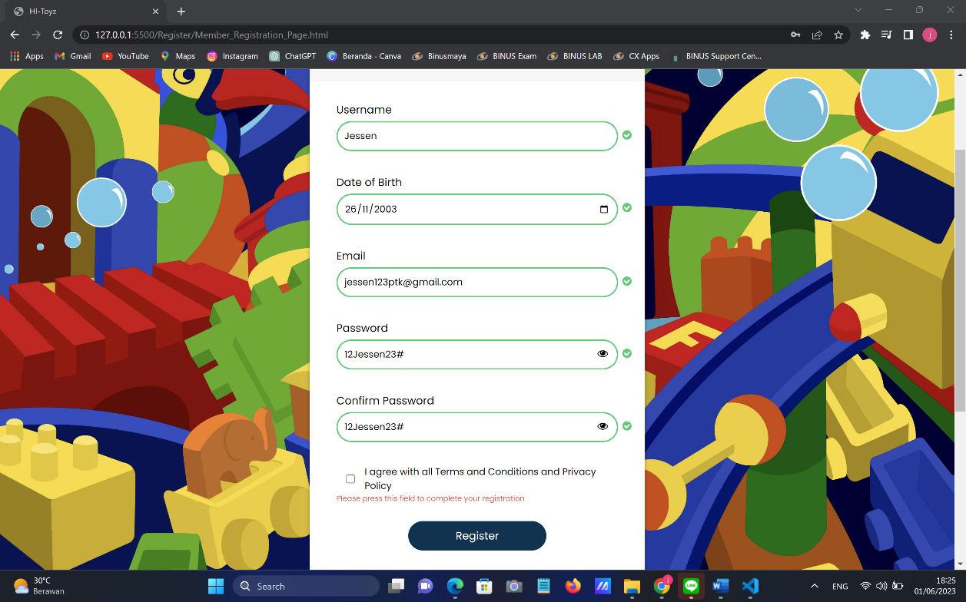

Jika pengguna menekan tombol register pada saat email dan password belum terisi dengan tepat atau belum menekan kotak di bagian agreement maka sistem akan menampilkan pesan error seperti pada gambar di atas.

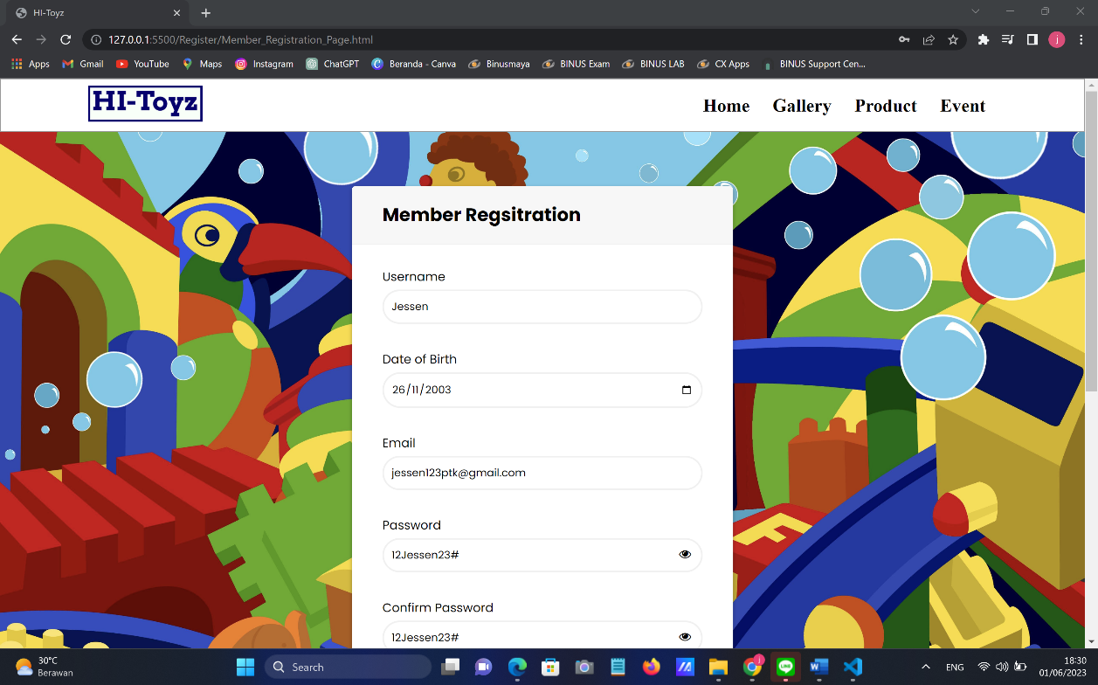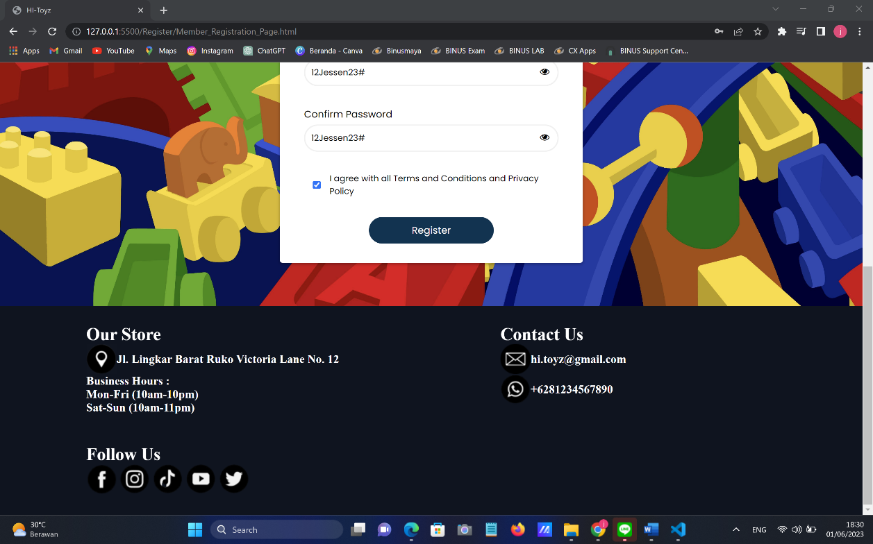

Beberapa kondisi yang harus dipenuhi antara lain:

* Username: pengguna dapat mengisi nama secara bebas.
* Date of Birth: pengguna dapat mengisi tanggal lahir secara bebas.
* Email: pengguna harus menggunakan format xxx@gmail.com
* Password: jumlah password 8-20 karakter, minimal 1 huruf besar (A..Z), 1 huruf kecil (a..z), 1 angka (0..9) dan 1 karakter unik (!@#$%&...).
* Agreement: pengguna harus menekan kotak di bagian agreement menjadi tombol centang.

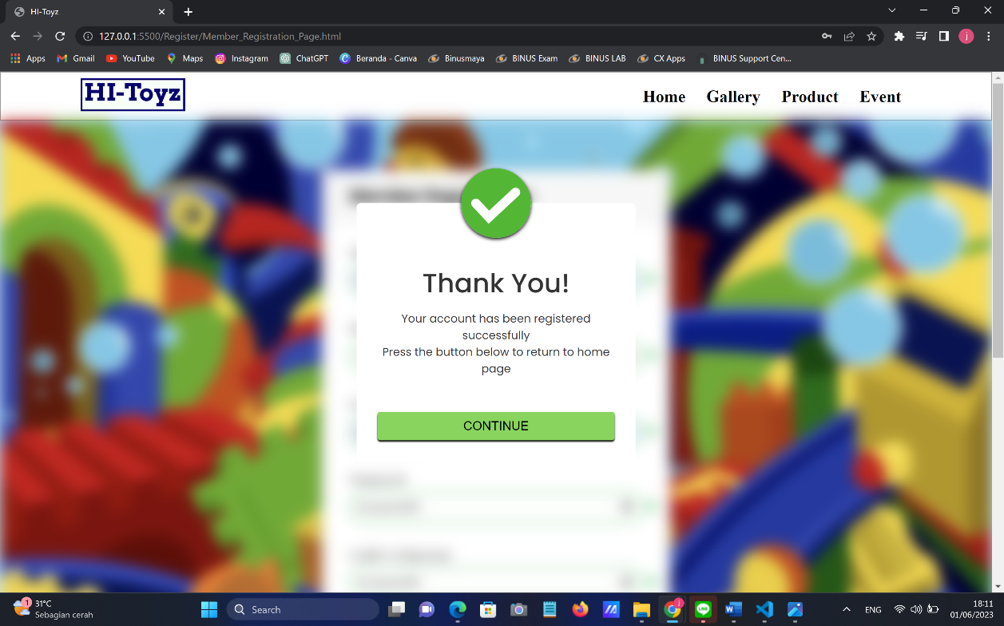

Jika pengguna sudah memenuhi semua kondisi dengan tepat, maka akan muncul popup seperti pada gambar di atas yang menunjukkan bahwa pengguna sudah berhasil didaftarkan sebagai member dari HI-Toyz.

1. Gallery Page

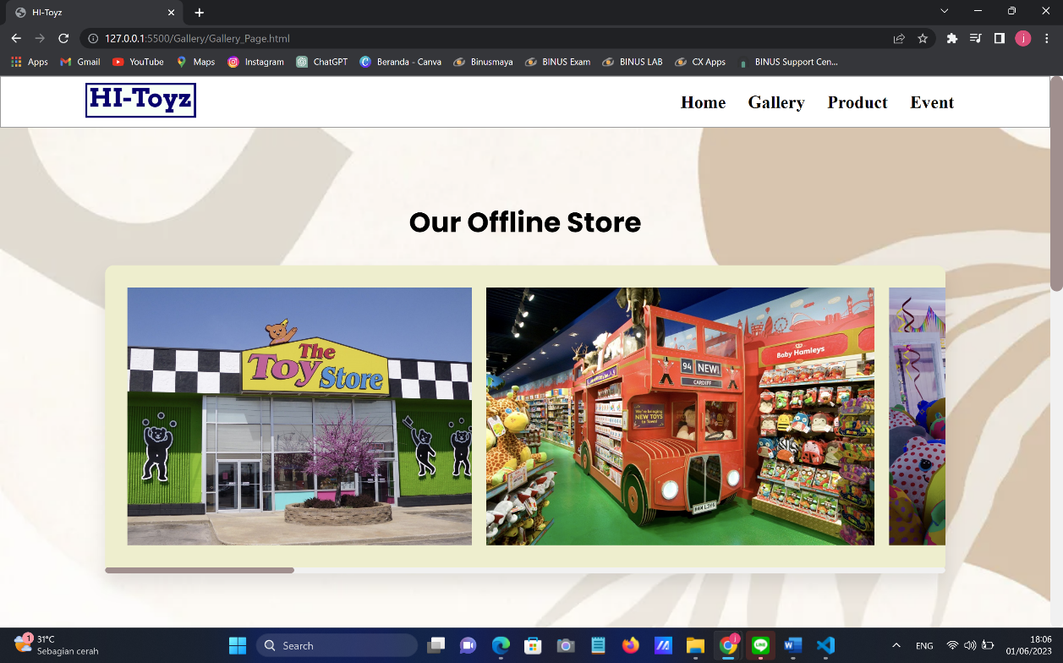

Bagian “Our Offline Store” akan menampilkan foto dari toko mainan HI-Toyz beserta design interiornya.

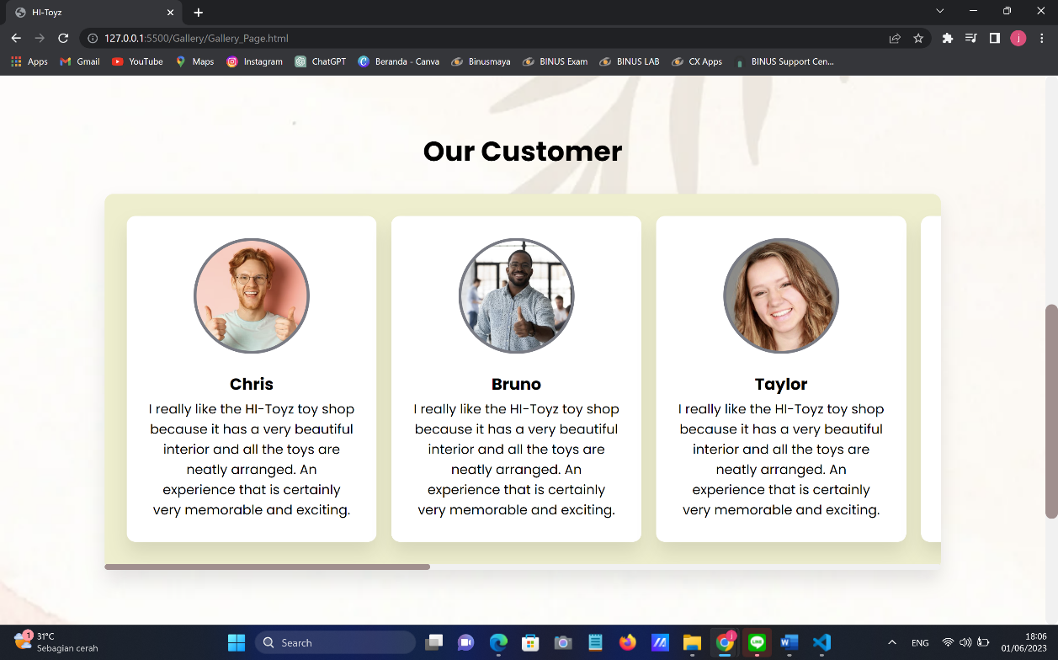

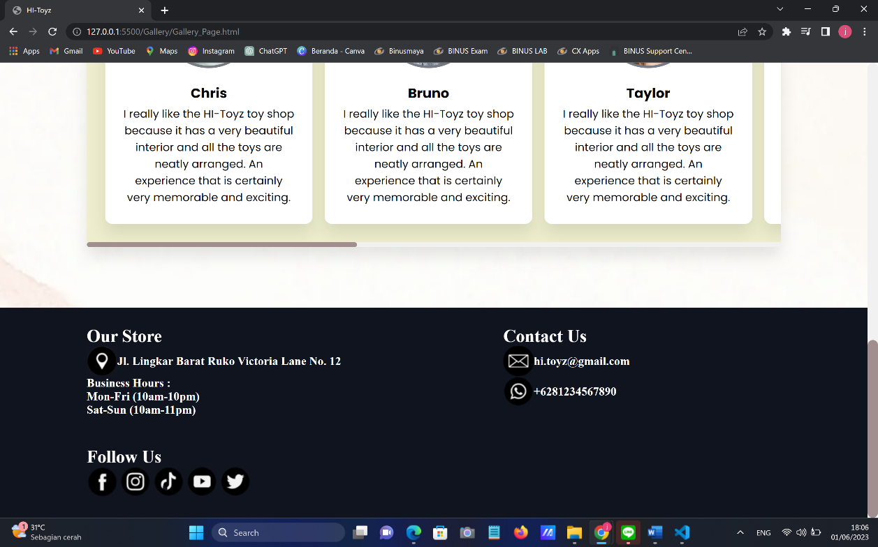

Bagian “Our Customer” menampilkan beberapa foto konsumen pilihan HI-Toyz yang pernah berbelanja secara offline beserta review dari masing-masing konsumen.

1. Product Page

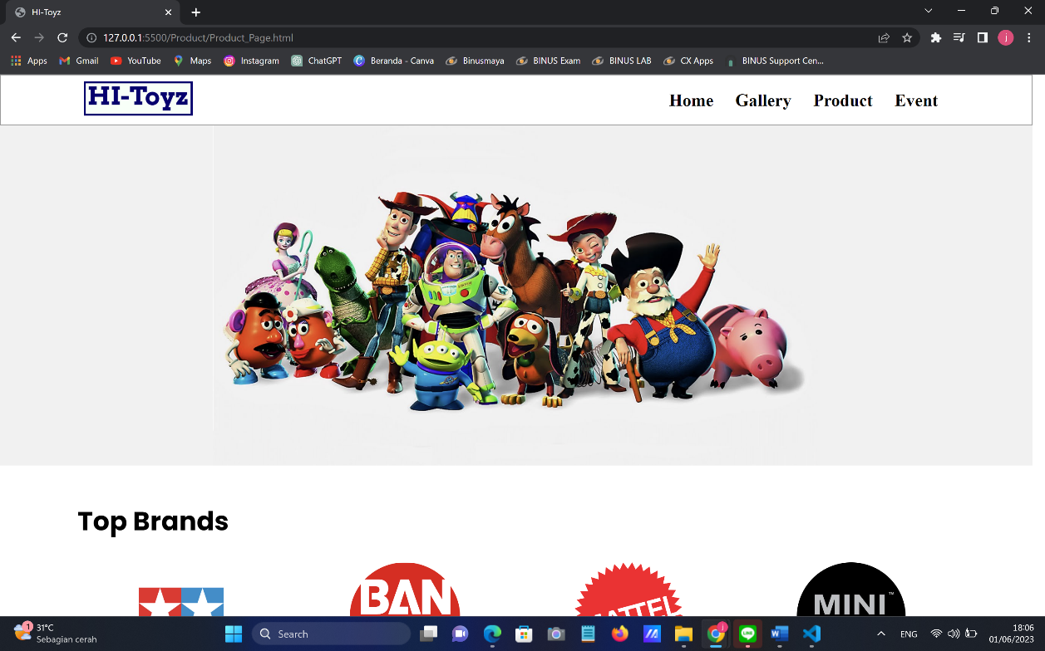

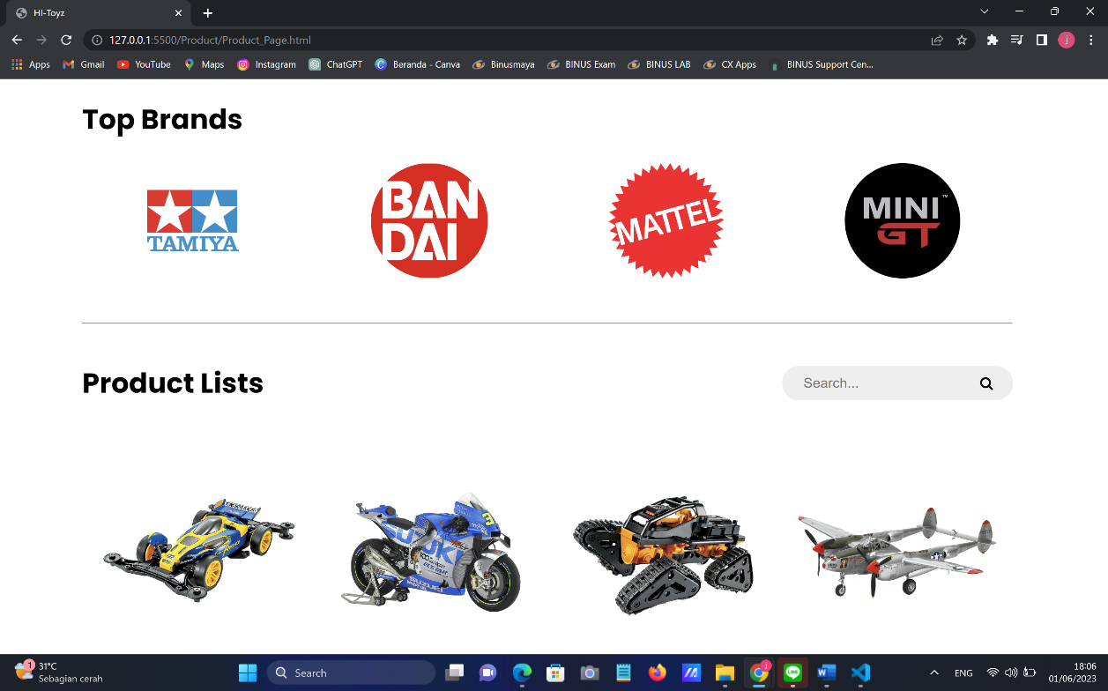

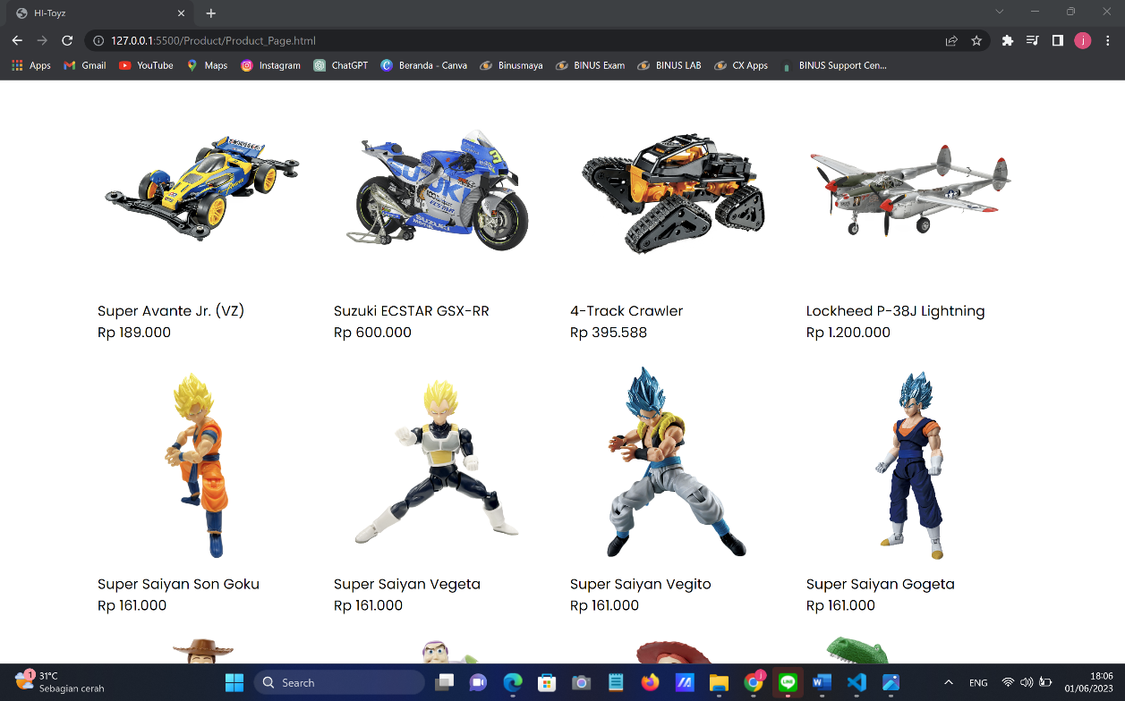

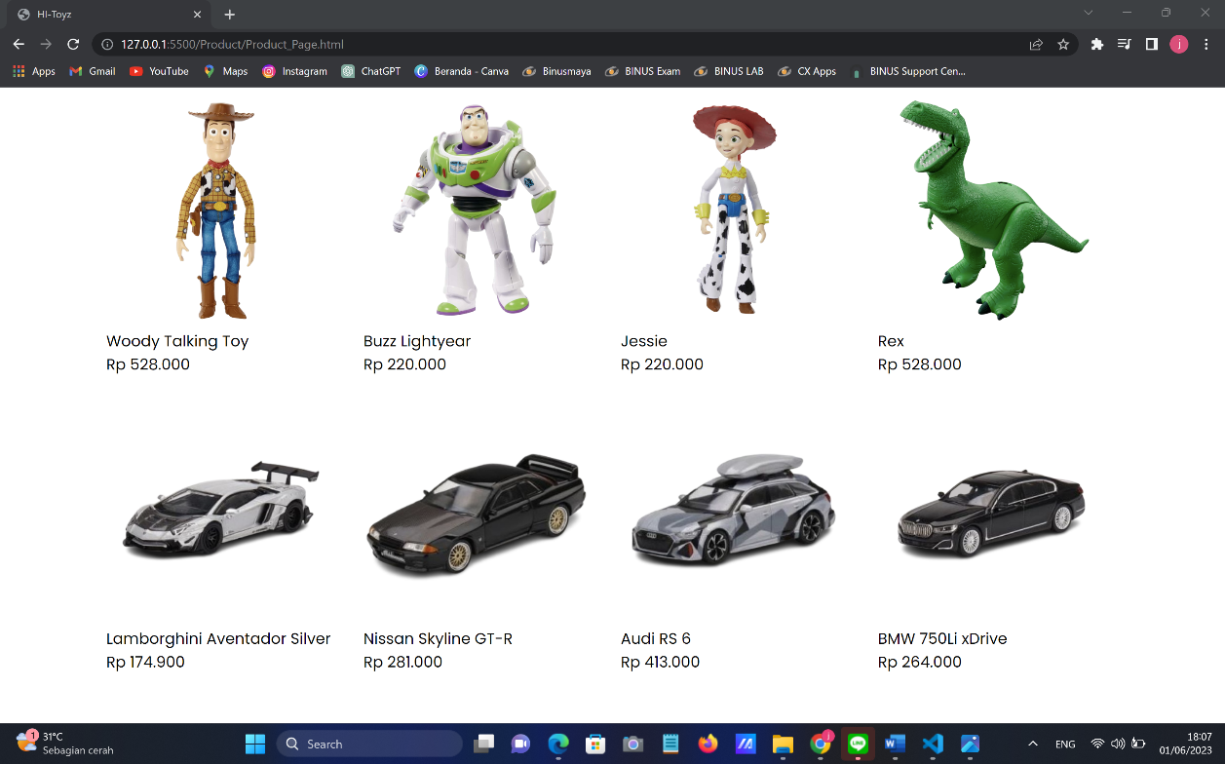

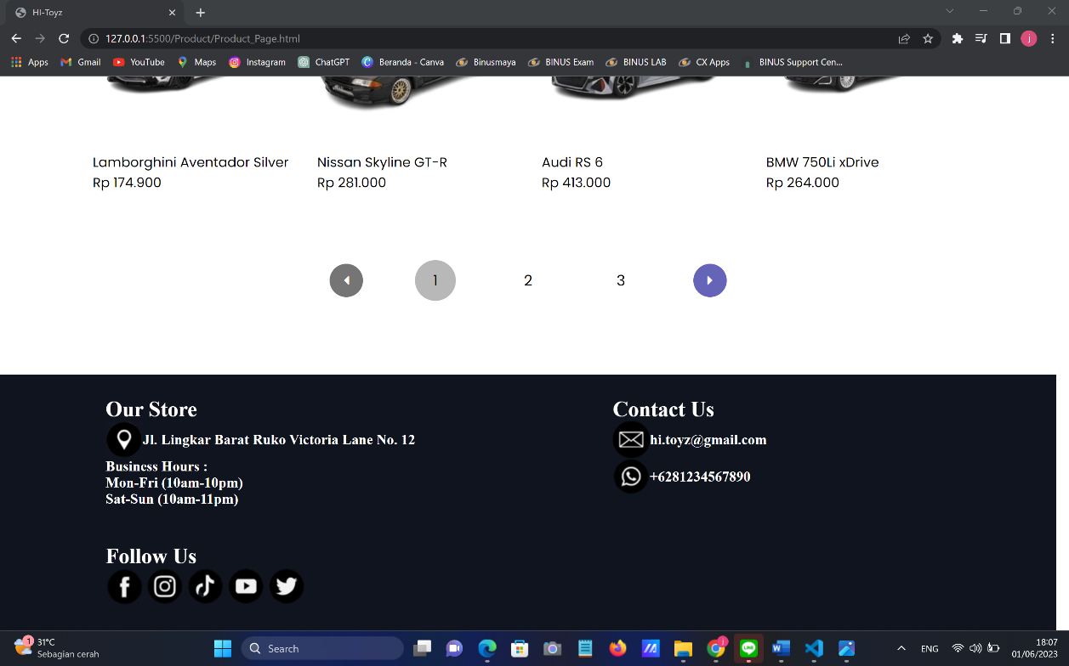

Halaman ini akan menampilkan beberapa merek yang dijual oleh HI-Toyz beserta dengan seluruh mainan yang dijual oleh HI-Toyz.

Halaman dari salah satu merek yang dijual oleh HI-Toyz (Tamiya):

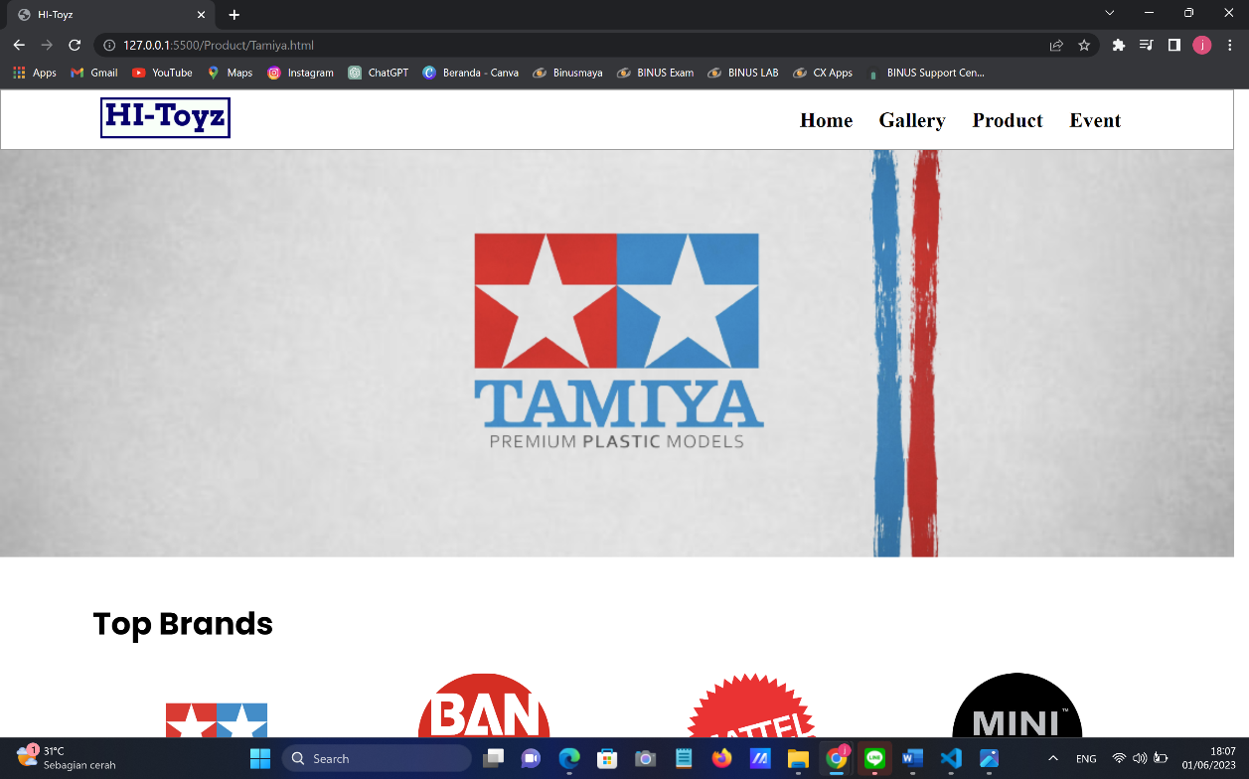

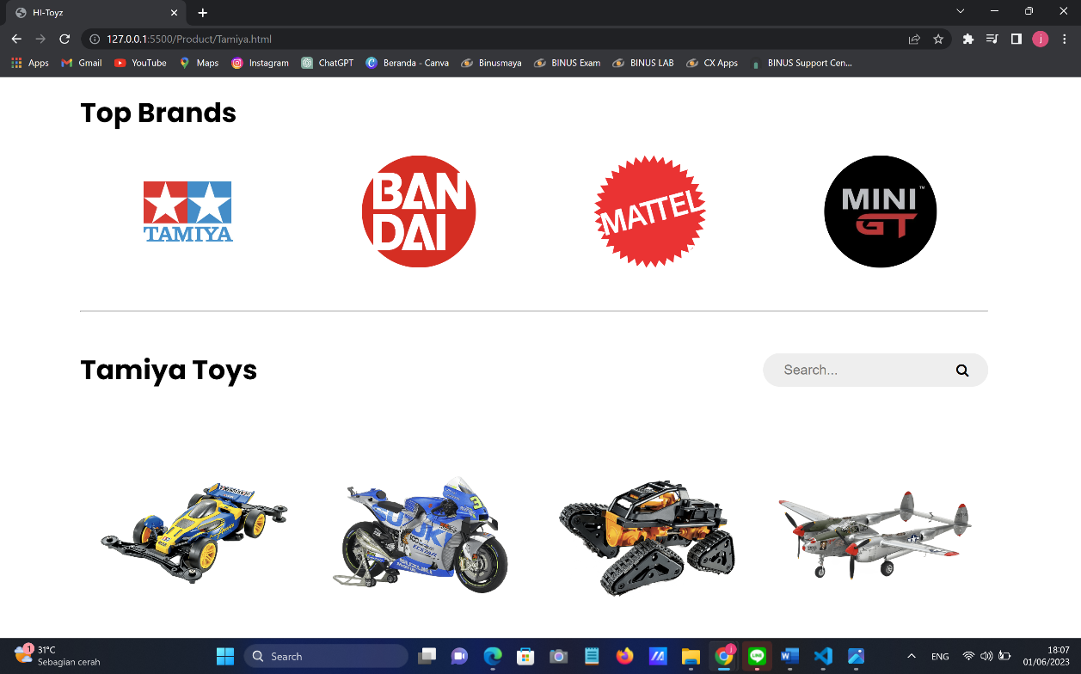

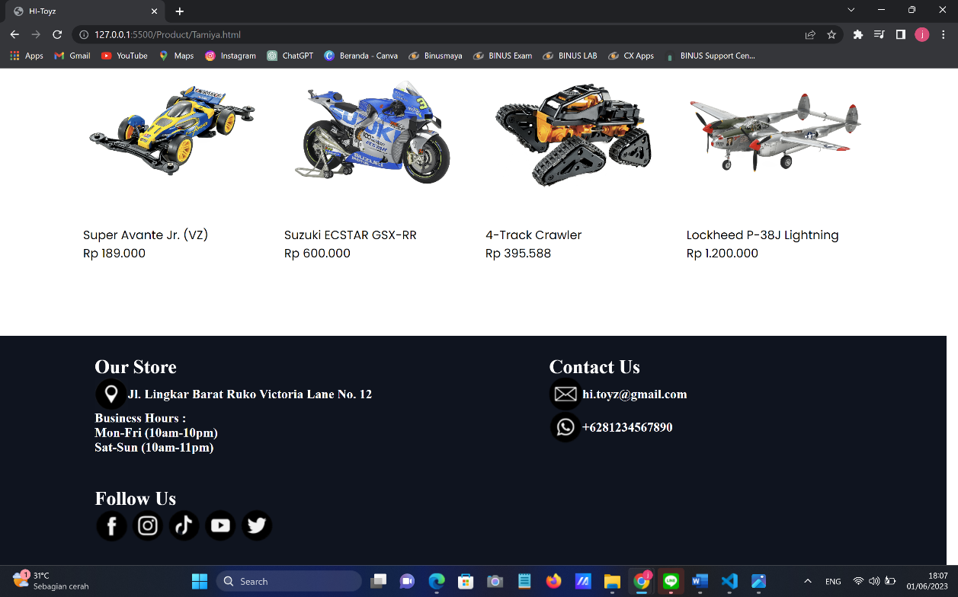

Halaman ini secara khusus akan menampilkan mainan dari merek yang dipilih oleh pengguna.

Halaman dari salah satu mainan HI-Toyz:

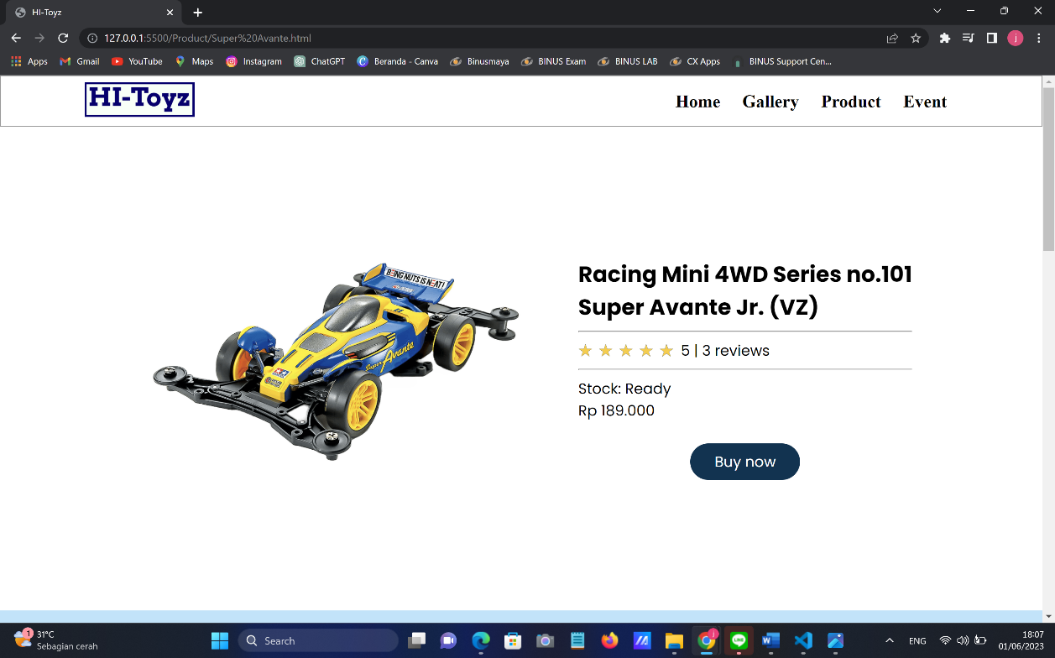

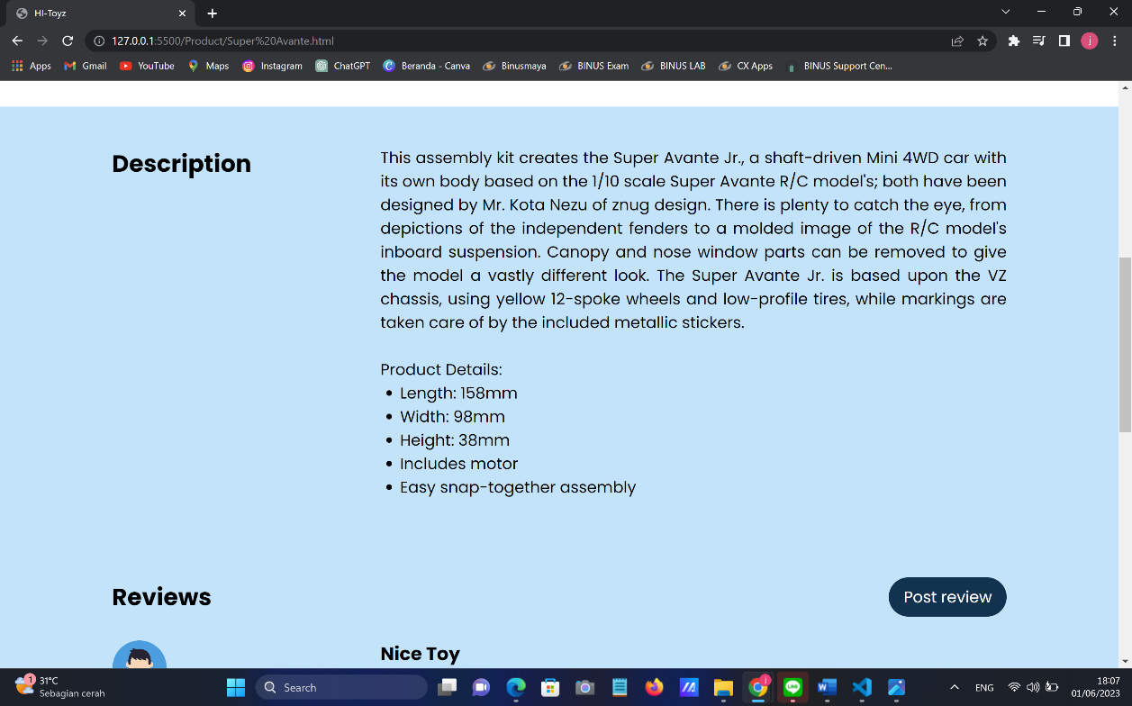

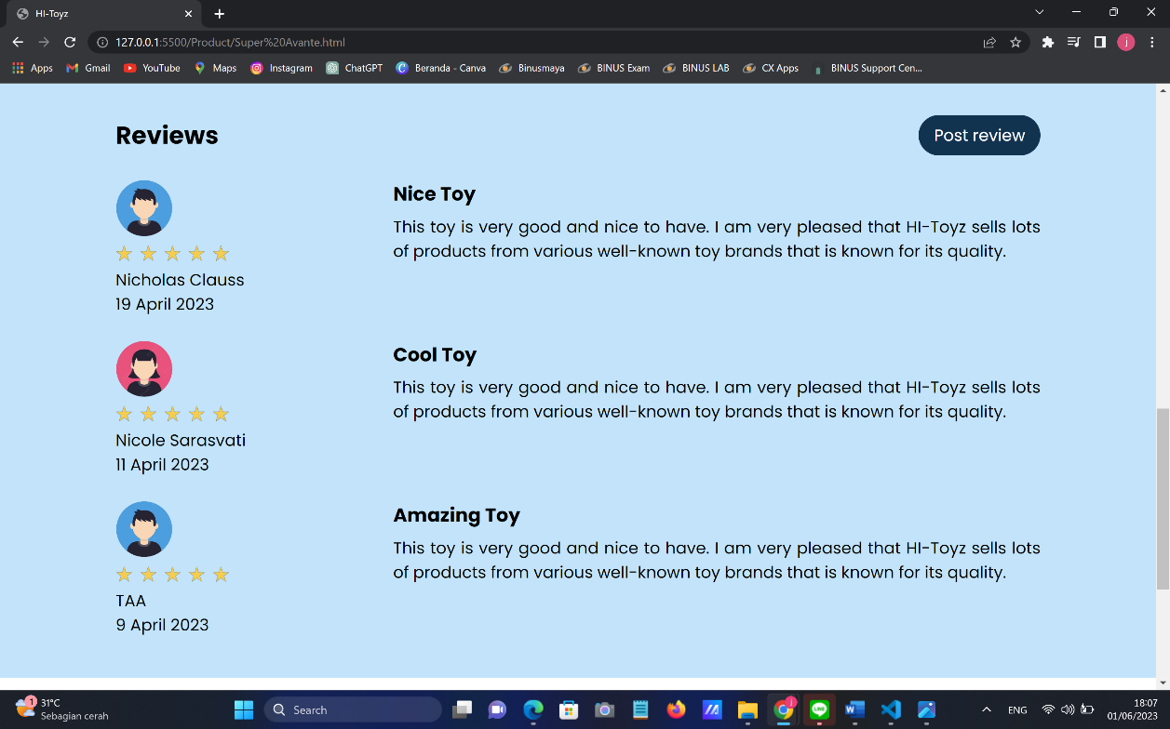

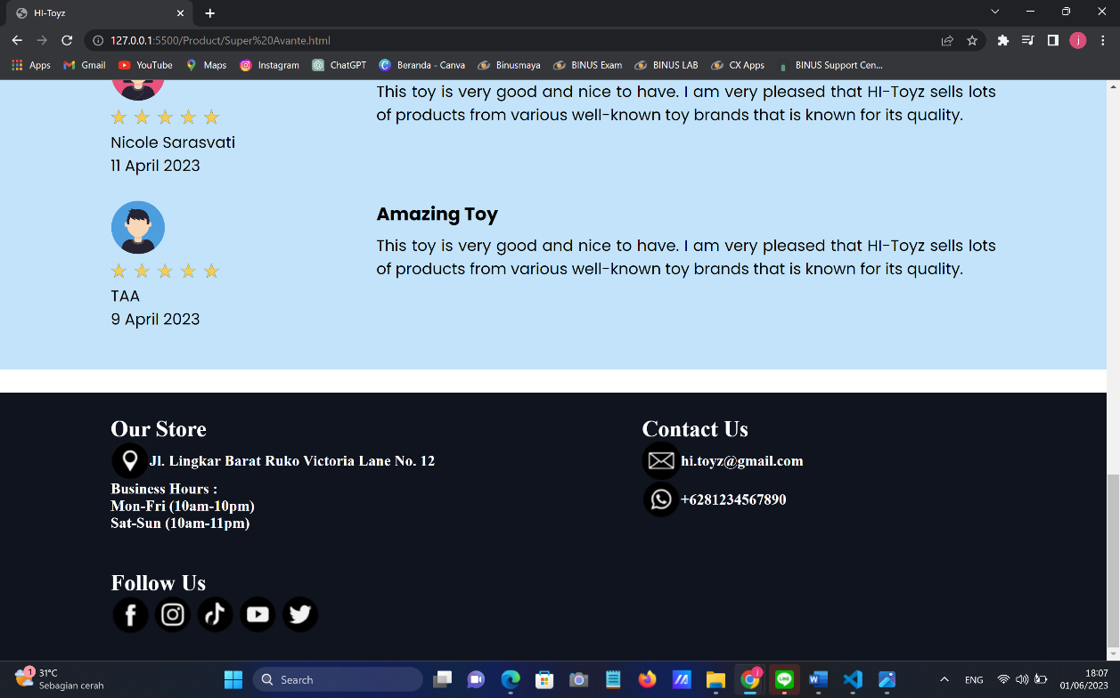

Halaman ini akan menampilkan gambar, harga, rating, stok mainan, deskripsi dari mainan beserta dengan review dari para konsumen.

1. Event Page

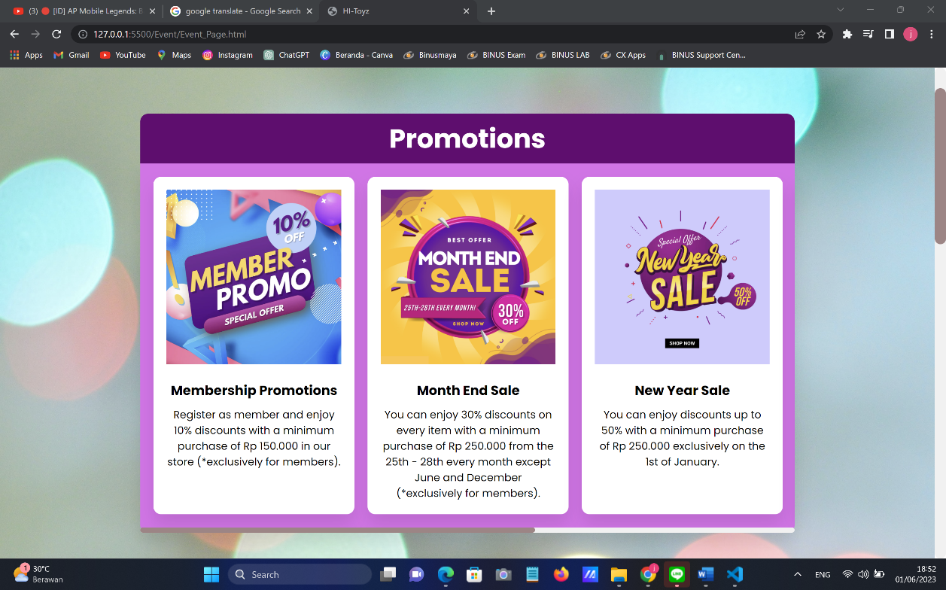

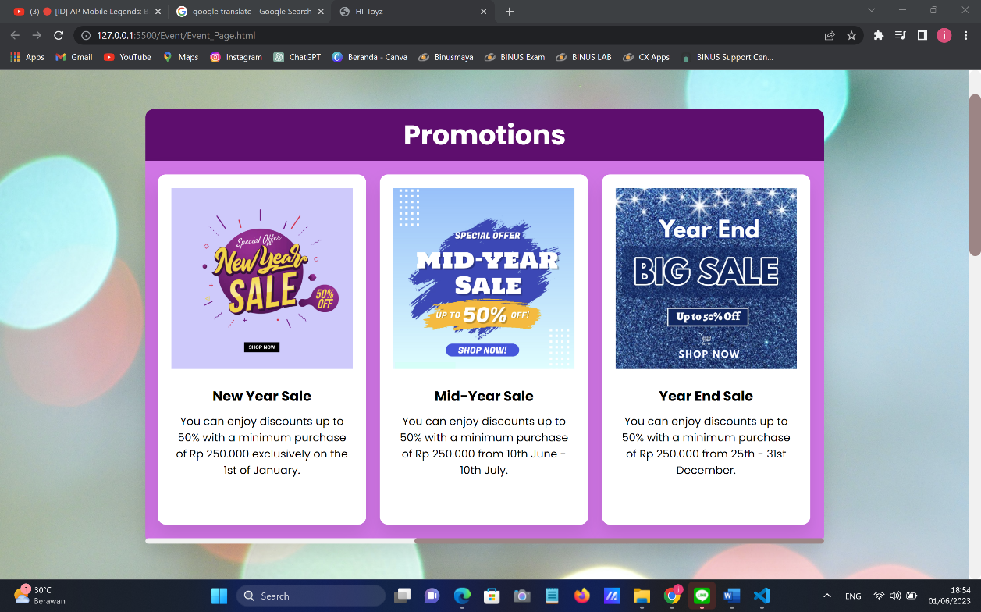

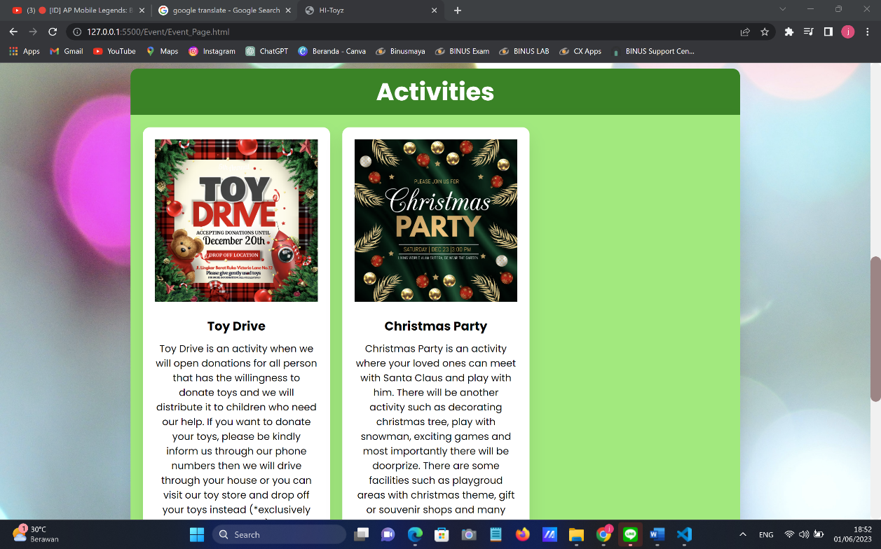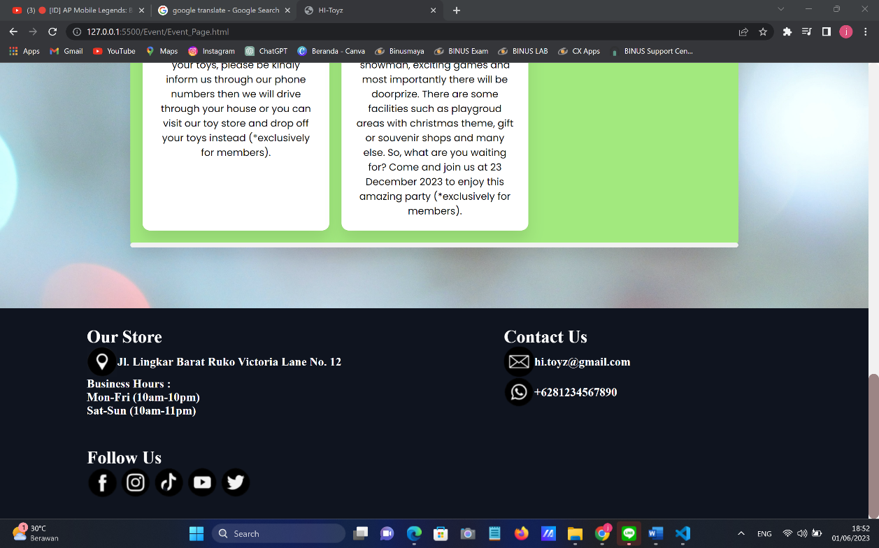

Halaman ini akan menampilkan beberapa promosi dan aktivitas/acara dari Hi-Toyz. Tentunya akan ada beberapa promosi ataupun acara yang hanya bisa dinikmati secara eksklusif oleh member saja.

Link Figma:

<https://www.figma.com/file/W3hX5E8AT4Tll0YouR89ox/Project-Lab?type=design&node-id=109%3A93&t=QNXipVtCSvz5YjGo-1>

Sumber

User Interface Idea: <https://www.toysrus.com/>

Logo: <https://logo.com/>

Header and Footer

* <https://www.google.com/url?sa=i&url=https%3A%2F%2Fwww.flaticon.com%2Ffree-icon%2Fmenu-bar_2311531&psig=AOvVaw0tGOl9FEqtJW_HWwPTLvST&ust=1684067536413000&source=images&cd=vfe&ved=0CBEQjRxqFwoTCIi68Mym8v4CFQAAAAAdAAAAABAI> (menu bar icon)
* <https://www.google.com/url?sa=i&url=https%3A%2F%2Fwww.pngwing.com%2Fen%2Ffree-png-bbsvl&psig=AOvVaw3PST2LWT6cUMFmfrNDTa7o&ust=1685698872678000&source=images&cd=vfe&ved=0CBEQjRxqFwoTCKiO9-Xjof8CFQAAAAAdAAAAABAU> (email icon)
* <https://www.google.com/url?sa=i&url=https%3A%2F%2Fwww.vecteezy.com%2Ffree-vector%2Flocation-icon-circle&psig=AOvVaw1jhdydwJmQMol_aqmzY8hE&ust=1685699031597000&source=images&cd=vfe&ved=0CBEQjRxqFwoTCKjK9rLkof8CFQAAAAAdAAAAABAU> (location icon)
* <https://www.google.com/url?sa=i&url=https%3A%2F%2Fwww.vecteezy.com%2Ffree-vector%2Fsocial-media-icons&psig=AOvVaw1V3wYTSWDIsla8BPMY1q1t&ust=1685698849815000&source=images&cd=vfe&ved=0CBEQjRxqFwoTCOiIhdvjof8CFQAAAAAdAAAAABAS> (social media icons)

Home Page

* <https://www.google.com/url?sa=i&url=https%3A%2F%2Fwww.pxfuel.com%2Fen%2Fdesktop-wallpaper-enrmm&psig=AOvVaw2RBrNjhza6LlFtCsJjbOpN&ust=1684912892315000&source=images&cd=vfe&ved=0CBEQjRxqFwoTCKDdjObziv8CFQAAAAAdAAAAABAR> (About us background image)
* <https://www.google.com/url?sa=i&url=https%3A%2F%2Fwww.istockphoto.com%2Fillustrations%2Fabout-us-team&psig=AOvVaw0XkIA9_xeZSGAI4YnwOQZf&ust=1684913268736000&source=images&cd=vfe&ved=0CBEQjRxqFwoTCOioxJn1iv8CFQAAAAAdAAAAABAE> (About us icon)
* <https://www.google.com/url?sa=i&url=https%3A%2F%2Fwallpaperaccess.com%2Fred-blue-yellow&psig=AOvVaw0WM4RYXBwlikAmJvQXiWJf&ust=1685273789295000&source=images&cd=vfe&ved=0CBEQjRxqFwoTCIimkJ-0lf8CFQAAAAAdAAAAABBA> (Items background image)

Registration Page

* <https://www.google.com/url?sa=i&url=https%3A%2F%2Fwallpapersafari.com%2Fkids-toys-wallpaper%2F&psig=AOvVaw02RTmF9hGZvc4HC4_bEisc&ust=1684771443054000&source=images&cd=vfe&ved=0CBEQjRxqFwoTCJCive3khv8CFQAAAAAdAAAAABAE> (background image)
* <https://www.google.com/url?sa=i&url=https%3A%2F%2Fcommons.wikimedia.org%2Fwiki%2FFile%3ACalendar_icon_2.svg&psig=AOvVaw0VpJKXwguoi2-ndfUStN2p&ust=1685370268349000&source=images&cd=vfe&ved=0CBEQjRxqFwoTCPD16dObmP8CFQAAAAAdAAAAABAE> (calender icon)
* <https://www.google.com/url?sa=i&url=https%3A%2F%2Ffontstruct.com%2Ffontstructions%2Fshow%2F1106896%2Fpassword_dots_2&psig=AOvVaw0FPGam_KXM_2oa_q3KscNB&ust=1685370873794000&source=images&cd=vfe&ved=0CBEQjRxqFwoTCMjGlvSdmP8CFQAAAAAdAAAAABAJ> (password icon)
* <https://www.google.com/url?sa=i&url=https%3A%2F%2Ftoppng.com%2Ffree-image%2Finvisible-vector-password-eye-icon-PNG-free-PNG-Images_174227&psig=AOvVaw2AwJcIn-r8eKaIoVoYhX55&ust=1685370357244000&source=images&cd=vfe&ved=0CBEQjRxqFwoTCLCDo_6bmP8CFQAAAAAdAAAAABAV> (hide password icon)
* <https://www.google.com/url?sa=i&url=https%3A%2F%2Fwww.flaticon.com%2Ffree-icon%2Fcheck_5610944&psig=AOvVaw1mEITFze2NdVzqfQLC2ZAQ&ust=1684758058519000&source=images&cd=vfe&ved=0CBEQjRxqFwoTCNDi_v6yhv8CFQAAAAAdAAAAABAZ> (tick icon)

Gallery Page

* <https://www.google.com/url?sa=i&url=https%3A%2F%2Fwww.pinterest.com%2Fpin%2Ffree-download-blue-pink-background-portrait-photography-abstract-texture-for-desktop-mobile-ta--464785624054516596%2F&psig=AOvVaw0ov-Ow-E65NpPYKdOCWRCZ&ust=1684840363519000&source=images&cd=vfe&ved=0CBEQjRxqFwoTCNimq83liP8CFQAAAAAdAAAAABAT> (gallery background image)
* <https://www.google.com/imgres?imgurl=https%3A%2F%2Ftownsquare.media%2Fsite%2F33%2Ffiles%2F2018%2F04%2FGettyImages-56558714.jpg%3Fw%3D980%26q%3D75&tbnid=QO7lnKBPc_h3xM&vet=12ahUKEwi3_LvOsrX-AhXuB7cAHfnVAGIQMygKegUIARDpAQ..i&imgrefurl=https%3A%2F%2F999ktdy.com%2Fold-toys-r-us-building-in-lafayette-could-become-new-toy-store%2F&docid=3JDLTwxftgeshM&w=980&h=663&q=toy%20store%20buildings&ved=2ahUKEwi3_LvOsrX-AhXuB7cAHfnVAGIQMygKegUIARDpAQ> (toy store image 1)
* <https://www.google.com/url?sa=i&url=https%3A%2F%2Fwww.interiordesignshop.net%2Fbest-places-shop-best-toy-stores-world%2F&psig=AOvVaw1WZ8E6c0g87nexaCEUfgC-&ust=1684842293483000&source=images&cd=vfe&ved=0CBEQjRxqFwoTCNC6t-XsiP8CFQAAAAAdAAAAABAb> (toy store image 2)
* <https://www.google.com/url?sa=i&url=https%3A%2F%2Fwww.unrealengine.com%2Fmarketplace%2Fen-US%2Fproduct%2Fcandy-and-toy-store&psig=AOvVaw31e_NaGRKRYT0VOMzGHmEZ&ust=1685365280746000&source=images&cd=vfe&ved=0CBEQjRxqFwoTCPi1wYmJmP8CFQAAAAAdAAAAABAE> (toy store image 3)
* <https://www.google.com/url?sa=i&url=https%3A%2F%2Fwww.nj.com%2Fbusiness%2F2021%2F10%2Funique-toy-retailer-opens-1st-nj-spot-offering-in-store-experiences.html&psig=AOvVaw1WZ8E6c0g87nexaCEUfgC-&ust=1684842293483000&source=images&cd=vfe&ved=0CBEQjRxqFwoTCNC6t-XsiP8CFQAAAAAdAAAAABAr> (toy store image 4)
* <https://www.google.com/url?sa=i&url=https%3A%2F%2Fwww.todaysparent.com%2Ffamily%2Ftoys%2Fbest-vancouver-toy-stores%2F&psig=AOvVaw2NMjC4zuDHwzu_cv3Tkzkm&ust=1684842557066000&source=images&cd=vfe&ved=0CBEQjRxqFwoTCNiaouPtiP8CFQAAAAAdAAAAABAO> (toy store image 5)
* <https://www.google.com/url?sa=i&url=https%3A%2F%2Fwww.thelondonmother.net%2Ftoy-shops-london%2F&psig=AOvVaw2NMjC4zuDHwzu_cv3Tkzkm&ust=1684842557066000&source=images&cd=vfe&ved=0CBEQjRxqFwoTCNiaouPtiP8CFQAAAAAdAAAAABAi> (toy store image 6)
* <https://www.google.com/url?sa=i&url=https%3A%2F%2Ftravellersworldwide.com%2Fbest-toy-stores-in-america%2F&psig=AOvVaw1WZ8E6c0g87nexaCEUfgC-&ust=1684842293483000&source=images&cd=vfe&ved=0CBEQjRxqFwoTCNC6t-XsiP8CFQAAAAAdAAAAABAE> (toy store image 7)
* <https://www.google.com/url?sa=i&url=https%3A%2F%2Fwww.frog.co%2Fwork%2Ftoys-r-us&psig=AOvVaw18P0WaBrXavckTtyiTQbRk&ust=1684844143612000&source=images&cd=vfe&ved=0CBEQjRxqFwoTCIiJ5NfziP8CFQAAAAAdAAAAABAE> (toy store image 8)
* <https://www.google.com/url?sa=i&url=https%3A%2F%2Fplanova.com%2Fdivisions%2Findustries%2Ftoy-and-childrens-store-design%2F&psig=AOvVaw18P0WaBrXavckTtyiTQbRk&ust=1684844143612000&source=images&cd=vfe&ved=0CBEQjRxqFwoTCIiJ5NfziP8CFQAAAAAdAAAAABAJ> (toy store image 9)
* <https://www.google.com/url?sa=i&url=https%3A%2F%2Fwww.freepik.com%2Ffree-photo%2Fface-satisfied-male-customer-showing-thumbs-up-approval-smiling-happy-wearing-glasses-t-shirt-pink-background_13096139.htm&psig=AOvVaw3LhkD3I-xsNCdiM3Had-ca&ust=1684043175186000&source=images&cd=vfe&ved=0CBEQjRxqFwoTCKDixezL8f4CFQAAAAAdAAAAABA5> (male customer 1)
* <https://www.google.com/url?sa=i&url=https%3A%2F%2Fblog.hubspot.com%2Fservice%2Fconsumer-psychology&psig=AOvVaw3LhkD3I-xsNCdiM3Had-ca&ust=1684043175186000&source=images&cd=vfe&ved=0CBEQjRxqFwoTCKDixezL8f4CFQAAAAAdAAAAABAJ> (male customer 2)
* <https://www.google.com/url?sa=i&url=https%3A%2F%2Fwww.rri.res.in%2Fpeople&psig=AOvVaw1psbKJsCLJziHMv8MVhqaD&ust=1684856735759000&source=images&cd=vfe&ved=0CBEQjRxqFwoTCPD0isyiif8CFQAAAAAdAAAAABBp> (male customer 3)
* <https://www.google.com/url?sa=i&url=https%3A%2F%2Fwww.istockphoto.com%2Fphoto%2Fportrait-of-handsome-latino-african-man-gm1007763808-271886202&psig=AOvVaw1psbKJsCLJziHMv8MVhqaD&ust=1684856735759000&source=images&cd=vfe&ved=0CBEQjRxqFwoTCPD0isyiif8CFQAAAAAdAAAAABBk> (male customer 4)
* <https://www.google.com/url?sa=i&url=https%3A%2F%2Fwww.touchsupport.com%2Fcustomer-support-guide-for-startups%2F&psig=AOvVaw0ecVn-OjW28hBD0zVpWZwQ&ust=1684043240418000&source=images&cd=vfe&ved=0CBEQjRxqFwoTCIiO2ovM8f4CFQAAAAAdAAAAABAF> (female customer 1)
* <https://www.google.com/url?sa=i&url=https%3A%2F%2Fwww.freepik.com%2Ffree-photo%2Fsatisfied-happy-female-customer-making-like-gesture_6628889.htm&psig=AOvVaw03ZUOF098woEerTAaupJNx&ust=1684044516896000&source=images&cd=vfe&ved=0CBEQjRxqFwoTCJj_q-zQ8f4CFQAAAAAdAAAAABAE> (female customer 2)
* <https://www.google.com/url?sa=i&url=https%3A%2F%2Fwww.skipprichard.com%2Flead-positive-what-highly-effective-leaders-see-say-and-do-2%2F&psig=AOvVaw1psbKJsCLJziHMv8MVhqaD&ust=1684856735759000&source=images&cd=vfe&ved=0CBEQjRxqFwoTCPD0isyiif8CFQAAAAAdAAAAABAz> (female customer 3)
* <https://www.google.com/url?sa=i&url=https%3A%2F%2Fdepositphotos.com%2Fstock-photos%2Fprofessional-thumbs-up.html&psig=AOvVaw1psbKJsCLJziHMv8MVhqaD&ust=1684856735759000&source=images&cd=vfe&ved=0CBEQjRxqFwoTCPD0isyiif8CFQAAAAAdAAAAABBE> (female customer 4)

Product Page

* <https://www.google.com/url?sa=i&url=https%3A%2F%2Fwallpapersafari.com%2Ftoy-story-wallpapers-hd%2F&psig=AOvVaw3tb8LF7cw7NiYiq_W0F-kO&ust=1685033659966000&source=images&cd=vfe&ved=0CBEQjRxqFwoTCKC7udi1jv8CFQAAAAAdAAAAABAd> (Product page wallpaper)
* <https://www.google.com/url?sa=i&url=https%3A%2F%2Fwallpaperaccess.com%2Ftamiya&psig=AOvVaw33aiNgxZS7mcv5BXNUI36U&ust=1685028440626000&source=images&cd=vfe&ved=0CBEQjRxqFwoTCIj32p-ijv8CFQAAAAAdAAAAABAE> (Tamiya wallpaper)
* <https://www.google.com/url?sa=i&url=https%3A%2F%2Fstock.adobe.com%2Fid%2Fsearch%3Fk%3Dgrey&psig=AOvVaw0GsI8uZ3GUuRVnKiGL1PRp&ust=1685029135083000&source=images&cd=vfe&ved=0CBEQjRxqFwoTCICO9-qkjv8CFQAAAAAdAAAAABAO> (Grey background)
* <https://www.google.com/url?sa=i&url=https%3A%2F%2Fwww.wallpaperbetter.com%2Fen%2Fsearch%3Fq%3DSuper%2BSaiyajin%2BBlue&psig=AOvVaw03a9SzkZqeo0oGuBM61sOj&ust=1685029844090000&source=images&cd=vfe&ved=0CBEQjRxqFwoTCPj74bynjv8CFQAAAAAdAAAAABAX> (Bandai wallpaper)
* <https://www.google.com/url?sa=i&url=https%3A%2F%2Fwallpaperaccess.com%2Fblue-aesthetic-desktop&psig=AOvVaw24IsqQ8ahexsbPQ2k9sI8Q&ust=1685031074946000&source=images&cd=vfe&ved=0CBEQjRxqFwoTCICQh4isjv8CFQAAAAAdAAAAABAE> (Blue background)
* <https://www.google.com/url?sa=i&url=https%3A%2F%2Fwallpapers.com%2Fwallpapers%2Fpixar-studios-toy-story-2-mk7wztcsw1irz51c.html&psig=AOvVaw29fNq2MOviiYIpJ7sZo0V3&ust=1683887394302000&source=images&cd=vfe&ved=0CBEQjRxqFwoTCNDnocKH7f4CFQAAAAAdAAAAABAE> (Mattel wallpaper)
* <https://www.google.com/url?sa=i&url=https%3A%2F%2Ftwitter.com%2FMINIGT64&psig=AOvVaw1wiar6RjUkH5qzJf0IXpsc&ust=1685031799653000&source=images&cd=vfe&ved=0CBEQjRxqFwoTCMjKnOGujv8CFQAAAAAdAAAAABAd> (MINI GT wallpaper)
* <https://www.google.com/url?sa=i&url=https%3A%2F%2Ffaithchurch.com%2Ffearlesslive%2Fattachment%2Fgrey-gradient-background-6-2%2F&psig=AOvVaw0RkjFvzhqJoeze5P8ZzgkE&ust=1685031563786000&source=images&cd=vfe&ved=0CBEQjRxqFwoTCOj48PCtjv8CFQAAAAAdAAAAABAT> (Gradient background)
* <https://www.google.com/url?sa=i&url=https%3A%2F%2Fvectorseek.com%2Fvector_logo%2Ftamiya-corporation-logo-vector%2F&psig=AOvVaw38wNWHih-bilo_5CHwOwiF&ust=1685006516745000&source=images&cd=vfe&ved=0CBEQjRxqFwoTCMCmxsnQjf8CFQAAAAAdAAAAABAE> (Tamiya logo)
* <https://www.google.com/url?sa=i&url=https%3A%2F%2F1000logos.net%2Fbandai-logo%2F&psig=AOvVaw1KAQtpDl3ooNLPwP1ltycU&ust=1685006558393000&source=images&cd=vfe&ved=0CBEQjRxqFwoTCMiml93Qjf8CFQAAAAAdAAAAABAI> (Bandai logo)
* <https://www.google.com/url?sa=i&url=https%3A%2F%2Fen.wikipedia.org%2Fwiki%2FMattel&psig=AOvVaw25vU8mchow-secEE8y4peB&ust=1685006238426000&source=images&cd=vfe&ved=0CBEQjRxqFwoTCIDE6cTPjf8CFQAAAAAdAAAAABAE> (mattel toys logo)
* <https://www.google.com/url?sa=i&url=https%3A%2F%2Fminigt.fandom.com%2Fwiki%2FMINI_GT&psig=AOvVaw2x9DKGYzimh5ZTjHs8DuGy&ust=1685006634828000&source=images&cd=vfe&ved=0CBEQjRxqFwoTCKiG0oHRjf8CFQAAAAAdAAAAABAk> (Mini GT logo)
* <https://www.tamiya.com/english/e-home.htm> (picture of Tamiya toys and its description)
* <https://www.bandai.com/> (picture of Bandai toys and its description)
* <https://shop.mattel.com/> (picture of Mattel toys and its description)
* <http://minigt.com/> (picture of Mini GT toys and its description)
* <https://www.google.com/url?sa=i&url=https%3A%2F%2Fuxwing.com%2Fsearch-icon&psig=AOvVaw0wXeLGHmR1yaMNuh9j0K0y&ust=1685364358025000&source=images&cd=vfe&ved=0CBEQjRxqFwoTCKi7g9GFmP8CFQAAAAAdAAAAABAE> (search icon)
* <https://www.google.com/url?sa=i&url=https%3A%2F%2Fumcommunities.org%2Fhealth-wellness%2Finside-the-medicare-5-star-rating-system%2F&psig=AOvVaw2Ru64lzHKuHOOpGv3BdbSh&ust=1681974605275000&source=images&cd=vfe&ved=0CBEQjRxqFwoTCKiuhOmxtf4CFQAAAAAdAAAAABAJ> (star rating)
* <https://www.google.com/url?sa=i&url=https%3A%2F%2Fwww.freepik.com%2Fpremium-vector%2Fmale-female-character-icon-set-vector-illustration-set-gender-symbols_30162078.htm&psig=AOvVaw3x7mf_0QvZi5XXFD0ArIH0&ust=1683346183502000&source=images&cd=vfe&ved=0CBEQjRxqFwoTCNi-56yn3f4CFQAAAAAdAAAAABAE> (customer icon)

Product Image and Informations:

* <https://www.tamiya.com/english/e-home.htm>
* <https://www.bandai.com/>
* <https://shop.mattel.com/>
* <http://minigt.com/>
* <https://shopee.co.id/MiniGT-LB-Works-Lamborghini-Aventador-Silver-MGT00449-i.43562654.23222392903?sp_atk=22fd6aa0-82c9-4024-8238-9e85d2a8d3a0&xptdk=22fd6aa0-82c9-4024-8238-9e85d2a8d3a0> (Lamborghini Aventador)
* <https://www.tokopedia.com/vvyl/mini-gt-87-nissan-skyline-gt-r-r32-black-w-bbs-lm-wheel?utm_source=google&utm_medium=organic&utm_campaign=pdp-seo> (Nissan Skyline GT-R)
* <https://www.tokopedia.com/ningnara-s/mini-gt-minigt-audi-rs6-avant-silver-digital-camouflage-w-roof-box> (Audi RS 6)
* <https://www.tokopedia.com/keziakezhop/mini-gt-436-bmw-750li-xdrive-black-sapphire?utm_source=google&utm_medium=organic&utm_campaign=pdp-seo> (BMW 750Li xDrive)

Event Page

* <https://www.google.com/url?sa=i&url=https%3A%2F%2Fwww.pexels.com%2Fsearch%2Fbackground%2F&psig=AOvVaw25peRrX69qJdyO-e8Scxlg&ust=1684924258333000&source=images&cd=vfe&ved=0CBEQjRxqFwoTCLj_9JGei_8CFQAAAAAdAAAAABAS> (activity background image)
* <https://id.postermywall.com/index.php/posterbuilder/load/5e8ef50dd3640d83d8c2f987d8c59ea8> (Membership Promotion)
* <https://id.postermywall.com/index.php/posterbuilder/load/031ce69d3520e9b425faf10e4f5309ed> (Mid Year Sale)
* <https://id.postermywall.com/index.php/posterbuilder/load/3f00a63b1dfbdbd4d68108250212dcee#.ZFSdbHZBzGI> (Month End Sale)
* <https://id.postermywall.com/index.php/posterbuilder/load/552aa091ee20fe693a733216992ef9b4#.ZFSllnZBzGI> (New Year Sale)
* <https://id.postermywall.com/index.php/posterbuilder/load/ca4d3f9899819fc825e79caecf607493> (Year End Sale)
* <https://id.postermywall.com/index.php/posterbuilder/load/fe6db2ceb4db7b4bf98444de073305ae> (Toy Drive)
* <https://id.postermywall.com/index.php/posterbuilder/load/6c4a040473c89cc06848b399368e5998> (Christmas Party)